About This Document

Overview

This document describes the steps to build and deploy and run WeatherWebApp Application.

What You Need

## Pre Requisites

## Supported Operating System

Windows XP/7

## Supported Browsers

Firefox 37.0.2 /Google Chrome/IE11

## Installed Software

Below is the list of software that should be installed on the system:

| **No.** | **Software** | **Version** |
| --- | --- | --- |
| 1 | Java Software Development Kit | 6 |
| 2 | Apache Maven | 3.2.5 |
| 3 | Apache Tomcat | 7.0.59 |

## Pre-set environment variables

| **Variable** | **Description** | **Remark** |
| --- | --- | --- |
| JAVA_HOME | The home directory for JDK. | Should be set to something like **C:\Program Files\Java\jdk1.6.0_45** |
| M2_HOME | The home directory for Maven. | **D:\apache-maven-3.2.5** |
| PATH | Add additionally the paths to java and maven **bin** directories. | PATH=%PATH%;**%JAVA_HOME/bin%;%M2_HOME%/bin** |

How to build

## Download and copy the project folder

Download the WeatherWebApp project folder from the provided ‘Github’ url and copy on to the system local disk.

Below shows the folder structure of the downloaded project folder downloaded to destination

‘D:\Workspace\WeatherWebApp’

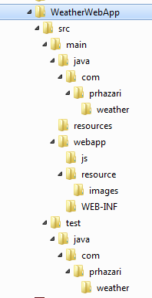

## Build the project

The project uses Maven build scripts. It is recommended to have some basic knowledge about Maven.

Steps to build:

1. Open command terminal from run.

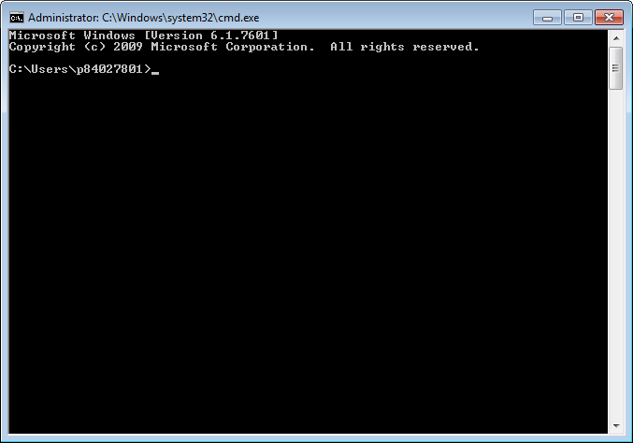

1. Navigate to project root directory. In this example ‘***D:\Workspace\WeatherWebApp’***

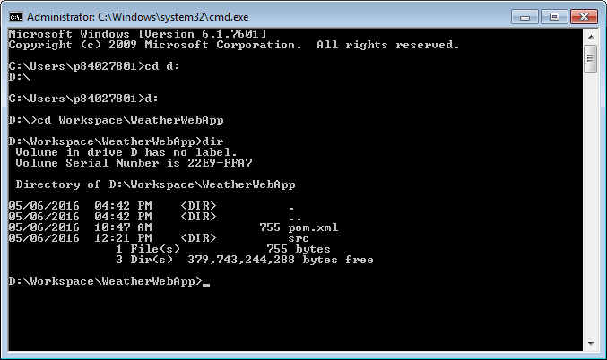

1. Check JAVA_HOME, M2_HOME and PATH variable is set properly:

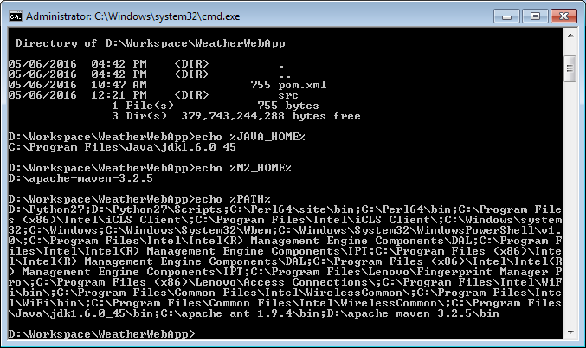

1. Build the project by executing below command:

‘mvn clean package’

D:\Workspace\WeatherWebApp>mvn clean package

[INFO] Scanning for projects...

[INFO]

[INFO] ------------------------------------------------------------------------

[INFO] Building WeatherWebApp Maven Webapp 1.0-SNAPSHOT

[INFO] ------------------------------------------------------------------------

[INFO]

[INFO] --- maven-clean-plugin:2.5:clean (default-clean) @ WeatherWebApp ---

[INFO]

[INFO] --- maven-resources-plugin:2.6:resources (default-resources) @ WeatherWeb

App ---

[WARNING] Using platform encoding (Cp1252 actually) to copy filtered resources,

i.e. build is platform dependent!

[INFO] Copying 1 resource

[INFO]

[INFO] --- maven-compiler-plugin:3.1:compile (default-compile) @ WeatherWebApp -

--

[INFO] Changes detected - recompiling the module!

[WARNING] File encoding has not been set, using platform encoding Cp1252, i.e. b

uild is platform dependent!

[INFO] Compiling 1 source file to D:\Workspace\WeatherWebApp\target\classes

[INFO]

[INFO] --- maven-resources-plugin:2.6:testResources (default-testResources) @ We

atherWebApp ---

[WARNING] Using platform encoding (Cp1252 actually) to copy filtered resources,

i.e. build is platform dependent!

[INFO] skip non existing resourceDirectory D:\Workspace\WeatherWebApp\src\test\r

esources

[INFO]

[INFO] --- maven-compiler-plugin:3.1:testCompile (default-testCompile) @ Weather

WebApp ---

[INFO] Changes detected - recompiling the module!

[WARNING] File encoding has not been set, using platform encoding Cp1252, i.e. b

uild is platform dependent!

[INFO] Compiling 1 source file to D:\Workspace\WeatherWebApp\target\test-classes

[INFO]

[INFO] --- maven-surefire-plugin:2.12.4:test (default-test) @ WeatherWebApp ---

[INFO] Surefire report directory: D:\Workspace\WeatherWebApp\target\surefire-rep

orts

-------------------------------------------------------

T E S T S

-------------------------------------------------------

Running com.prhazari.weather.AppTest

Root element :listOfCities

----------------------------

City Name :Sydney

City Name :Melbourne

City Name :Wollongong

Tests run: 1, Failures: 0, Errors: 0, Skipped: 0, Time elapsed: 0.04 sec

Results :

Tests run: 1, Failures: 0, Errors: 0, Skipped: 0

[INFO]

[INFO] --- maven-war-plugin:2.2:war (default-war) @ WeatherWebApp ---

[INFO] Packaging webapp

[INFO] Assembling webapp [WeatherWebApp] in [D:\Workspace\WeatherWebApp\target\W

eatherWebApp]

[INFO] Processing war project

[INFO] Copying webapp resources [D:\Workspace\WeatherWebApp\src\main\webapp]

[INFO] Webapp assembled in [38 msecs]

[INFO] Building war: D:\Workspace\WeatherWebApp\target\WeatherWebApp.war

[INFO] WEB-INF\web.xml already added, skipping

[INFO] ------------------------------------------------------------------------

[INFO] BUILD SUCCESS

[INFO] ------------------------------------------------------------------------

[INFO] Total time: 2.801 s

[INFO] Finished at: 2016-06-05T18:32:25+10:00

[INFO] Final Memory: 10M/245M

[INFO] ------------------------------------------------------------------------

D:\Workspace\WeatherWebApp>

The command will run compile the project. If the build is successful the included Junit test case passes the final war file ‘***WeatherWebApp.war*’** will be created under ‘***D:\Workspace\WeatherWebApp\targe****t*’ folder.

How to run unit test

Navigate to project folder and run ‘mvn test’

D:\Workspace\WeatherWebApp>mvn test

[INFO] Scanning for projects...

[INFO]

[INFO] ------------------------------------------------------------------------

[INFO] Building WeatherWebApp Maven Webapp 1.0-SNAPSHOT

[INFO] ------------------------------------------------------------------------

[INFO]

[INFO] --- maven-resources-plugin:2.6:resources (default-resources) @ WeatherWeb

App ---

[WARNING] Using platform encoding (Cp1252 actually) to copy filtered resources,

i.e. build is platform dependent!

[INFO] Copying 1 resource

[INFO]

[INFO] --- maven-compiler-plugin:3.1:compile (default-compile) @ WeatherWebApp -

--

[INFO] Nothing to compile - all classes are up to date

[INFO]

[INFO] --- maven-resources-plugin:2.6:testResources (default-testResources) @ We

atherWebApp ---

[WARNING] Using platform encoding (Cp1252 actually) to copy filtered resources,

i.e. build is platform dependent!

[INFO] skip non existing resourceDirectory D:\Workspace\WeatherWebApp\src\test\r

esources

[INFO]

[INFO] --- maven-compiler-plugin:3.1:testCompile (default-testCompile) @ Weather

WebApp ---

[INFO] Nothing to compile - all classes are up to date

[INFO]

[INFO] --- maven-surefire-plugin:2.12.4:test (default-test) @ WeatherWebApp ---

[INFO] Surefire report directory: D:\Workspace\WeatherWebApp\target\surefire-rep

orts

-------------------------------------------------------

T E S T S

-------------------------------------------------------

Running com.prhazari.weather.AppTest

Root element :listOfCities

----------------------------

City Name :Sydney

City Name :Melbourne

City Name :Wollongong

Tests run: 1, Failures: 0, Errors: 0, Skipped: 0, Time elapsed: 0.065 sec

Results :

Tests run: 1, Failures: 0, Errors: 0, Skipped: 0

[INFO] ------------------------------------------------------------------------

[INFO] BUILD SUCCESS

[INFO] ------------------------------------------------------------------------

[INFO] Total time: 1.902 s

[INFO] Finished at: 2016-06-05T19:16:12+10:00

[INFO] Final Memory: 7M/309M

[INFO] ------------------------------------------------------------------------

D:\Workspace\WeatherWebApp>

How to deploy

## Copy the war file to Apache Tomcat Server

Copy the recently built application war file, ***WeatherWebApp.war***, from last set to ‘webapps’ under installation folder

e.g. ‘***D:\apache-tomcat-7.0.59\webapps***’

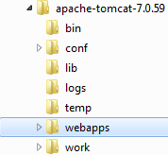

## Restart Apache Tomcat Server

Execute below scripts by navigating to bin folder under tomcat installation one after another.

shutdown.sh 🡪 startup.bat

Wait sure and make sure tomcat server is completely initialize, up and running

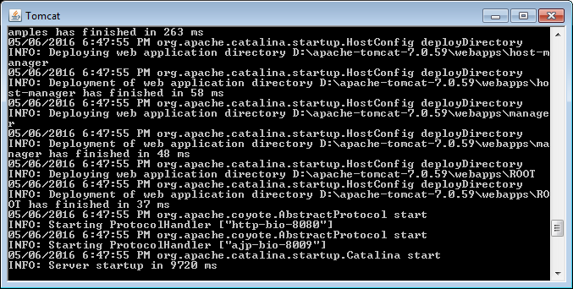

*Note: No need to execute shutdown.bat if tomcat server is not running.*

## Access the WeatherWebApp from brower

Open the url ‘ <http://localhost:8080/WeatherWebApp/>’ from supported browser:

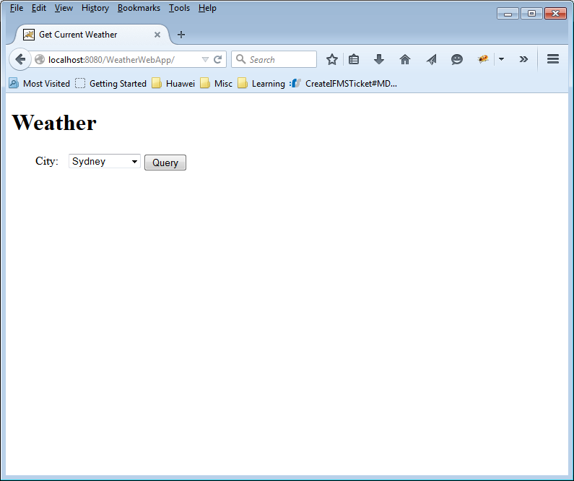

How to use

The application supports both manual query of weather information of the listed city by clicking on the  button next to click.

The information is also automatically retrieved when the user selects different city.

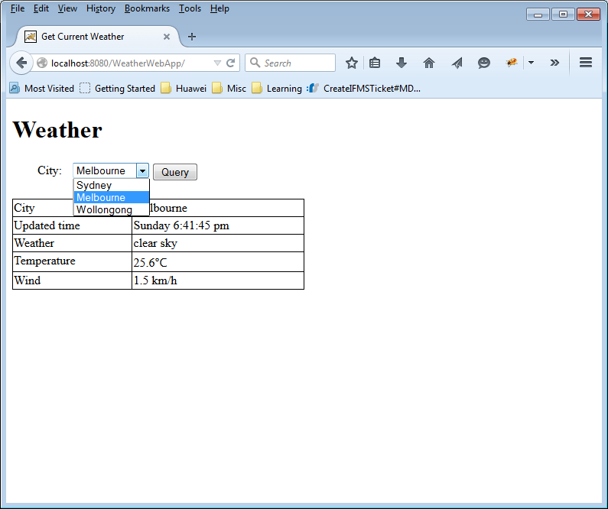

How to Configure

## Modify/add/delete new cities

The list of cities displayed in the dropdown list is being loaded dynamically from resource file ‘CityList.xml’ under project resource folder.

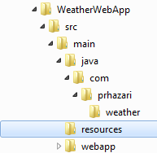

The contents of the file looks like below:

<?xml version="1.0" encoding="UTF-8"?>

<listOfCities>

<city>Sydney</city>

<city>Melbourne</city>

<city>Wollongong</city>

</listOfCities>

One could modify or add new cities to the list.

*Note: Even though it is possible to modify the resource file directly under Tomact exploded folder for WeatherWebApp folder. It is* ***\*highly\**** *recommended to modify it under project folder. Then build and deploy the war file again to Tomact webapps server.*

Troubleshooting

## Common Error

If something like below is been seen, it normally means that the application encounter communication error or other exception while getting data from online Weather API.

***Suggested Action : Please check your internet connection and try again.***

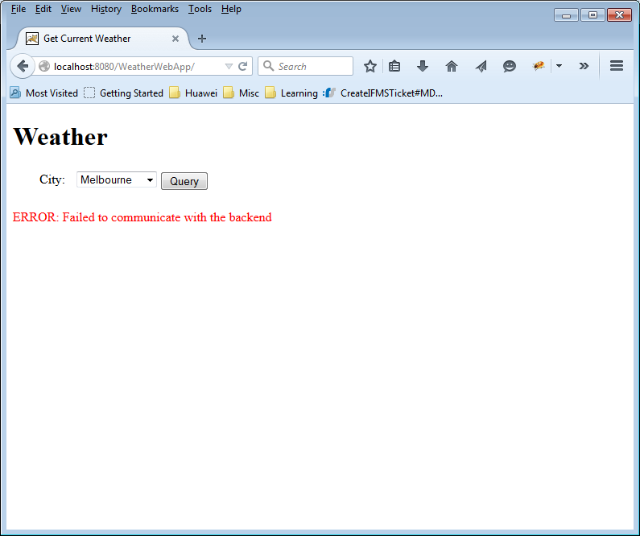

## Authentication Error

The application uses open source weather API from <http://api.openweathermap.org/>. The access is control by access string ‘APPID’.

If one sees authentication from than renew AppId should be obtained from the owner.

This parameter is configurable and could be set by modifying ‘appID’ field in the file ‘D:\Workspace\WeatherWebApp\src\main\webapp\resource\config.js’

Rebuild and deploy the war file to tomcat server. Tomcat Server should be restarted.